**26.How to build simple linear regression model using python?**

**Objective:**

* To build simple linear regression model for train data in python.

**Process:**

* Import necessary libraries.
* Load the sample data set.
* Assign the independent(X) and dependent(y) variables.
* Pass the variables to the model.
* Check normality of variable.
* Test the correlation.
* Build the linear model from sklearn library.

**Input:**

* Data set(sample).

**Output:**

* Simple linear regression model.
* Regression co-efficients.
* Regression intercept.

**Source code:**

#import the libraries

import pandas as pd

import scipy

from scipy import stats

#import correlation test method

from scipy.stats import kendalltau

from sklearn.linear_model import LinearRegression

#Load the sample data

data={'salary':[100,200,300,400,500,400,300,200,100,50], 'age':[25,26,25,23,30,29,23,23,25,25],

'rating':[4,3.24,2.5,2.25,2,2.25,2.5,2.75,3.2,4.2], 'bonus':[2500,1200,900,3000,1800,1400,850,250,750,

1000]}

#Measuring descriptive statistics

df=pd.DataFrame(data)

print("Descriptive statistics\n",df.describe())

#Take independent variable

X = df.iloc[:, :1].values

#Check normality

st=scipy.stats.shapiro(X)

print("Normality test result\n",st)

#Take dependent variable

y = df.iloc[:, 3].values

#Correlation test

p=kendalltau(X,y)

print("Correlation result is\n",p)

#building linear model

regressor = LinearRegression()

#Fit the variable to the linear model

t=regressor.fit(X, y)

#print the results

print("Regression intercept is",regressor.intercept_)

print("Regression coefficient is",regressor.coef_)

**Screen shots:**

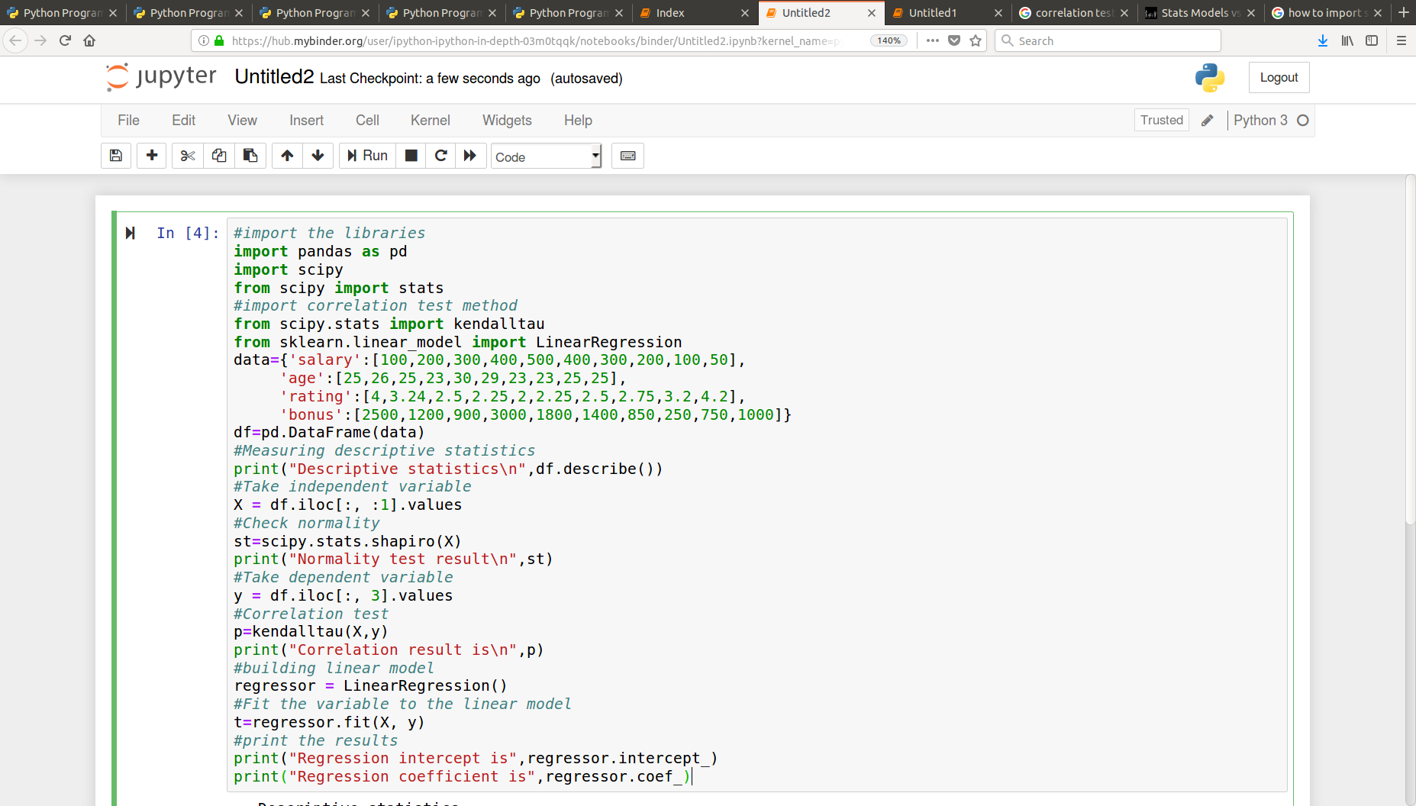

**Output:**

